Adithya.J

230701013 CSE A

EXP NO:3a Shell Script –Reverse the Digit

PROGRAM

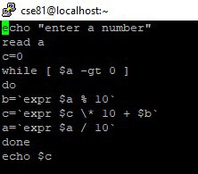

OUTPUT

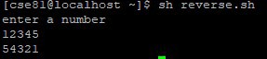

EXP NO:3b Fibbonacci Series

PROGRAM

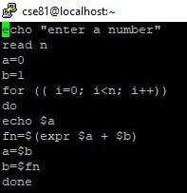

OUTPUT

